CONFERENCE SESSION NAME

**Features of Child Development in the Digital Sphere**

**Vitalyi N. Ivanov**

Saint Petersburg State University, Saint Petersburg, Russia  
ORCID: <https://orcid.org/0000-0002-0777-1111>, [e-mail: ivanov@yandex.ru](mailto:ivanov@yandex.ru)

**Vladimir N. Petrov**

Moscow State University of Psychology & Education, Moscow, Russia  
ORCID: <https://orcid.org/0000-0002-0777-1122>, [e-mail: petrov@yandex.ru](mailto:petrov@yandex.ru)

Summary 120-150 words, Times New Roman 12 pt, single interval.

***Keywords:*** up to 8 key words. Times New Roman 12 pt, single interval.

**Funding.** The reported study was funded by Russian Foundation for Basic Research (RFBR), project number 20-01-00001

**Acknowledgements.** The authors are grateful for assistance in data collection Ivanov T.Yu.

**For citation:** Ivanov V.N., Petrov V.N. Features of Child Development in the Digital Sphere *//* *Digital Humanities and Technology in Education (DHTE 2025): Collection of Articles of the V International Scientific and Practical Conference. November 13–14, 2025* / V.V. Rubtsov, M.G. Sorokova, N.P. Radchikova (Eds). Moscow: Publishing house MSUPE, 2025. _–_ p. (In Russ., abstr. in Engl.).

**Introduction**

The article should clearly formulate the problem under consideration, the approach used to solve it, and outline the main results obtained. The structure of the text, as a rule, should contain the following information:

* *Introduction*: indication of the main objectives of the study, including theoretical foundations and research questions;
* *Methods:* it is necessary to describe the research procedure, participants (and their number), measurements (methods) and analysis;
* *Results:* brief information about the main results, including important statistical information, description of the main scientific effects, main conclusions;
* *Discussion*: conclusion or discussion about the application of the outcomes obtained;

Exceptions are theoretical reviews. The structure of a theoretical article should be the following: introduction, main part, findings and conclusion.

Preference is given to articles containing the results of empirical research.

The text of the article must be **at least 15,000 characters long** with spaces, including all sections (title, author information, abstract, keywords, bibliography, etc.). Tables (Table 1) and figures (Fig. 1) are allowed. The text must be typed in Times New Roman, 12 font size, line spacing 1, justified alignment. The document margins must be set with the following values: left margin - 2 cm, right - 2 cm; top/bottom - 2 cm; first line indent - 0.5 cm.

When formatting the text, page breaks, forced hyphens, prohibition of orphan lines, etc. must not be used. When surnames are mentioned in the text, initials must be indicated before them. The space is not placed between the initials, but after them before the surname.

Example: I.I. Ivanov, G. Smith

Abbreviations must be presented in full form when they first appear in the text, figures or tables and must be indicated in a uniform form throughout the text.

It is not recommended to emphasize big text fragments with italic/bold. No more than 5-7% of the text can be emphasized.

Please use the accepted format for statistical indicators:

* Rounding: descriptive statistics (mean, standard deviation) up to 1-2 decimal places, values and significance level of statistical criteria – 3-4 decimal places;
* Basic statistical criteria: value (degrees of freedom)=___, p=___ (table. 1);

After the significance, specifying the size of the effect is welcome.

Tables shall be created in MS Word (Table > add table) or MS Excel. Manually typed tables (by means of many spaces without allocation to cells) are not acceptable. Tables should contain no more than ten columns and have an informative heading. Abbreviated words in tables are inacceptable. Tables are numbered in Arabian figures consequently as there are mentioned in the text. In table headings the word “Table” and its corresponding number are aligned right. No point at the end. Table name shall be typed in the next line after number of the table. No point at the table. Name is typed in bold and center aligned. Example:

Table 1

**Examples of the design of the results of statistical hypothesis testing in the text**

|  |  |  |
| --- | --- | --- |
| Name of criterion / statistical method | Example | Variant of effect size measures |
| Pearson or Spearman correlation coefficient | r=-0,16; p=0,83 |  |
| Student's t-criterion | t (26)=2,58, p=0,008 | Cohen’s d |
| Analysis of variance | F(2,54)=3,78; p=0,029 | η2 or η2р |
| Pearson's Chi-square test | χ2(3)=1,01; p=0,797 |  |

Table 2

**Descriptive statistics for creativity and aggression:  
mean ± standard deviation**

|  |  |  |  |
| --- | --- | --- | --- |
| Group | age, full years | Number of mutual elections | Self-assessment (T.T. Testikov's test) |
| Boys | 5,03±0,5 | 2,03±0,7 | 15,15±1,5 |
| Girls | 5,24±0,6 | 2,24±0,8 | 14,01±1,6 |

Table 3

**Descriptive statistics for all measured variables: mean ± standard deviation,**

**median [lower quartile; upper quartile], minimum, and maximum (N=406)**

|  |  |  |  |  |
| --- | --- | --- | --- | --- |
| Questionnaires and scales | M  ± SD | Me  [LQ; UQ] | Min | Max |
| Activity-Related Experiences Assessment technique (AREA) | | | | |
| Effort | 12,8 ± 3,4 | 13 [11; 15] | 3 | 18 |
| Pleasure | 11,5 ± 3,9 | 12 [9; 14] | 3 | 18 |
| Meaning | 14,0 ± 3,7 | 15 [12; 17] | 3 | 18 |
| Void | 7,7 ± 3,6 | 7 [5; 10] | 3 | 18 |

***Pictures and drawings.*** All pictures should be included into the text of the article in relevant places. The picture should be understandable, clear, inscriptions shall correspond to text content. If scans are used, scanned pictures should be made in maximal scanning dimension. Photos are submitted in undamaged condition. Minimal format of the photos is 800x600 px (size – no less than 1 Mb). Authors are responsible for quality of pictures and diagrams. Title should be typed below the picture. Abbreviation “Fig.” and its corresponding number are typed in italics. Title of the picture is not emphasized. Example: Fig.1. Semantic area of role positions dynamics …

Example:

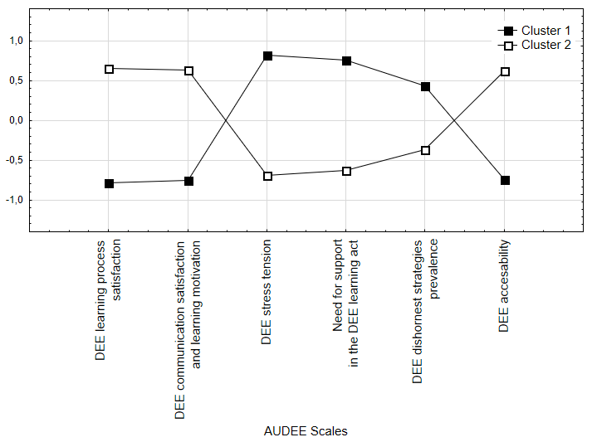

*Fig. 1*. *k*-means cluster analysis results

Any materials, theory, statement, study published earlier should be followed by a reference to a source of literature. The reference list will be well-organized, alphabetized, and easy to navigate.

### ****Use of Modern Sources:****

* **Recent Studies:** The reference list should primarily contain sources published within the past 5 years. This ensures your work is up to date and reflects the current state of the field.
* **Self-Citation Limit:** The total number of references to your own works, including co-authored papers, should not exceed 10% of the sources cited. This rule ensures that the work is well-rounded and not overly focused on the author’s previous contributions.

### ****Source List Organization:**** The list should be sorted alphabetically by the first author's last name.

### ****Citation Style:****

* **APA Style (7th Edition):** All references and in-text citations must be formatted according to the guidelines set out in the APA Manual of Scientific Publications (7th edition, 2020). Here are some key rules for citations:
  + **In-text citations**: When citing sources in the text, use parentheses with the author's last name and the year of publication. If directly quoting, add the page number.
    - Example for a paraphrase: (Smith, 2020)
    - Example for a direct quote: (Smith, 2020, p. 15)
  + **Reference List**: Each entry in the reference list should follow a specific format depending on the type of source. For example:
    - **Journal article**:
      * Smith, J. (2020). The role of trauma in psychological resilience*.* Journal of Psychological Research, 15(2), 123-145. https://doi.org/10.1234/jpsr.2020.015
    - **Book**:
      * Johnson, A., & Brown, L. (2019). Psychological trauma and coping strategies. Academic Press.
    - **Edited Book Chapter**:
      * Williams, R. (2021). The impact of personal virtues on psychological well-being. In S. Green (Ed.), Psychological well-being in the 21st century (pp. 120-135). Oxford University Press.
    - **Online Source**:
      * Davis, C. (2022, March 14). The influence of social media on mental health in young adults. Psychology Today. https://www.psychologytoday.com/articles/mental-health-media

### ****Handling Page Numbers:****

* If citing a specific part of a source, be sure to include the page number in the in-text citation.
  + Example: (Smith, 2020, p. 30) – This refers to a quote or specific idea on page 30 of Smith’s 2020 article.
  + If it's a general reference to the whole work, omit the page number.

### ****Peer-Reviewed Sources:****

* **Priority for Peer-Reviewed Journals and Books:** The reference list should consist mostly of peer-reviewed academic articles, books, and scholarly reports. Avoid citing non-peer-reviewed sources unless they are directly relevant and authoritative for the field.

### ****Specific Citation Instructions for Russian and English Sources:****

* **Russian References:** should be translated.
  + Example:
    - Zuboff, S. (2015). Big other: surveillance capitalism and the prospects of an information civilization. *Journal of Information Technology*, *30*, 75—89. https://doi.org/10.1057/jit.2015.5.
    - Oslon V.N., Odintsova M.A., Semya G.V., Kolesnikova U.V. (2024) Motivation for the Admission of Orphans of Employable Categories in the Context of Various Forms of Family Structure*. Psychological Science and Education*, *29*(6), 81–98. https://doi.org/10.17759/pse.2024290606

### References (example)

Fodor, L.A., Coteț, C.D., Cuijpers, P., Szamoskozi, Ș., David, D., Cristea, I.A. (2018). The effectiveness of virtual reality based interventions for symptoms of anxiety and depression: A meta-analysis. *Scientific Reports*, *8*(1), Article 10323. https://doi.org/10.1038/s41598-018-28113-6

Johnson, A., & Brown, L. (2019). Psychological trauma and coping strategies. Academic Press

Smith, J. (2020). The role of trauma in psychological resilience*.* Journal of Psychological Research, 15(2), 123-145. https://doi.org/10.1234/jpsr.2020.015

Information about the authors

*Vitalyi N. Ivanov,* PhD in Psychology, Leading Research Associate, Associate Professor, Chair of Psychology, Saint Petersburg State University, Saint Petersburg, Russia, ORCID: https://orcid.org/0000-0002-0777-111[1, e-mail: ivanov@yandex.ru](mailto:ivanov@yandex.ru)

*Vladimir N. Petrov,* PhD in Psychology, Leading Research Associate, Center of Applied Psychological Studies, Moscow State University of Psychology & Education, Moscow, Russia, ORCID: https://orcid.org/0000-0002-0777-1122, [e-mail: petrov@yandex.ru](mailto:petrov@yandex.ru)