CONFERENCE SESSION NAME

Activity Experience of First-Year Students

Vitalyi N. Ivanov
Saint Petersburg State University, Saint Petersburg, Russia
ORCID: https://orcid.org/0000-0002-0777-1111, e-mail: ivanov@yandex.ru

Vladimir N. Petrov
Moscow State University of Psychology & Education, Moscow, Russia
ORCID: https://orcid.org/0000-0002-0777-1122, e-mail: petrov@yandex.ru
Summary: 150-200 words, Times New Roman, 12 pt. Single interval. Abstract text shall not be divided into paragraphs.
Keywords: up to 8 key words – activity-related experience, quality of motivation, self-determination theory, intrinsic motivation, extrinsic motivation, academic motivation.
Funding. The reported study was funded by Russian Foundation for Basic Research (RFBR), project number 20-01-00001
Acknowledgements. The authors are grateful for assistance in data collection Ivanov T.Yu.
For citation: Ivanov V.N., Petrov V.N. Features of Child Development in the Digital Sphere // Digital Humanities and Technology in Education (DHTE 2024): Collection of Articles of the V Interenational Scientific and Practical Conference with International Participation. November 14–15, 2024 / V.V. Rubtsov, M.G. Sorokova, N.P. Radchikova (Eds). Moscow: Publishing house MSUPE, 2024. _–_ p.
Introduction [Times New Roman, 12-point, bold, centered]

Please, insert the text keeping the format and styles. The final paper length should be more than 15,000 signs with spaces (including all sections: title, information about the authors, annotation, keywords, list of references, etc. in English). References are indicated in square brackets, separated by a semicolon [1 ; 3]. References are given in alphabetical order: first in Cyrillic, then in Latin. Tables (Table 1) and figures (Fig. 1) are allowed.
The text must be in Times New Roman font, 12 pt, alignment - to the width of the page. Left padding is 0.5.
The abstracts should clearly state: the problem under consideration, the approach used to solve it, and the main outcomes obtained. The structure of the text should contain the following information:
- Introduction: indication of the main objectives of the study, including theoretical foundations and research questions;
- Methods: it is necessary to describe the research procedure, participants (and their number), measurements (methods) and analysis;
- Results: brief information about the main results, including important statistical information, description of the main scientific effects, main conclusions;
- Discussion: conclusion or discussion about the application of the outcomes obtained;

Manual hyphenations and footnotes are not allowed in the text. Document margins shall be put with values: ▪ Left margin: 2 cm, right: 2 cm; upper/lower: 2 cm ▪ First line indent: 1,25 cm.
Abbreviations must be presented in full form when they first appear in the text, figures or tables and must be indicated in a uniform form throughout the text.
It is not recommended to emphasize big text fragments with italic/bold. No more than 5-7% of the text can be emphasized.
Typing last names in the text shall be after initials. No space is between initials. But a space shall be between initials and last name. Decimal fractions shall be typed with a comma. (0,25 instead of 0.25). Such « » quotation marks shall be used. If other quoted words occur within words in quotation marks, then « » are used as external and „ “ as internal quotation marks. Quotation marks and brackets are not separated with spaces from the words inside them.
Figures and graphs must have a clear image and be made in black and white (it is possible to use black shading, without toning).
Formulas must be executed in the built-in MS Equation Editor.
Please use the accepted format for statistical indicators:
- Rounding: descriptive statistics (mean, standard deviation) up to 1-2 decimal places, values and significance level of statistical criteria – 3 decimal places;
- Basic statistical criteria: value (degrees of freedom)=___, p=___ (table. 1);
after the significance, specifying the size of the effect is welcome.
Tables shall be created in MS Word (Table > add table) or MS Excel. Manually typed tables (by means of many spaces without allocation to cells) are not acceptable. Tables shall contain no more than ten columns and have an informative heading. Abbreviated words in tables are inacceptable. Tables are numbered in Arabian figures consequently as there are mentioned in the text. In table headings the word “Table” and its corresponding number are aligned right. No point at the end. Table name shall be typed in the next line after number of the table. No point at the table. Name is typed in bold and center aligned. Example:

Table 1
Examples of the design of the results of statistical hypothesis testing in the text
Name of criterion / statistical method | Example | Variant of effect size measures
Pearson or Spearman correlation coefficient | r=-0,16; p=0,83
Student's t-criterion | t (26)=2,58, p=0,008 | Cohen’s d
Analysis of variance | F(2,54)=3,78; p=0,029 | η² or η²_{р}
Pearson's Chi-square test | χ²(3)=1,01; p=0,797

Table 2
Descriptive statistics for creativity and aggression:
mean ± standard deviation
Group | age, full years | Number of mutual elections | Self-assessment (T.T. Testikov's test)
Boys | 5,03±0,5 | 2,03±0,7 | 15,15±1,5
Girls | 5,24±0,6 | 2,24±0,8 | 14,01±1,6

Table 3
Descriptive statistics for all measured variables: mean ± standard deviation,
median [lower quartile; upper quartile], minimum, and maximum (N=406)
Questionnaires and scales | M ± SD | Me  [LQ; UQ] | Min | Max
Activity-Related Experiences Assessment technique (AREA)
Effort | 12,8 ± 3,4 | 13 [11; 15] | 3 | 18
Pleasure | 11,5 ± 3,9 | 12 [9; 14] | 3 | 18
Meaning | 14,0 ± 3,7 | 15 [12; 17] | 3 | 18
Void | 7,7 ± 3,6 | 7 [5; 10] | 3 | 18

Pictures and drawings. All pictures shall be compulsory included into the text of the article in respective places. The picture shall be understandable, clear, inscriptions shall correspond to text content. If scans are used, scanned pictures shall be made in maximal scanning dimension. Photos are submitted in undamaged condition. Minimal format of the photos is 800x600 px (size – no less than 1 Mb). Authors are responsible for quality of pictures and diagrams. Title shall be typed below the picture. Abbreviation “Fig.” and its corresponding number are typed in italics. Title of the picture is not emphasized. Example: Fig.1. Semantic area of role positions dynamics… If there is a single picture in publication, it has number and its layout is the same. All pictures shall be referenced in the text. All inscriptions inside the picture shall be capitalized. If a picture is referenced, it shall be abbreviated as “fig.” Example: Average response time in younger group is more than in elder (fig. 1). All legends to illustrations (diagrams, graphs etc.) are given under the picture as follows. Example:

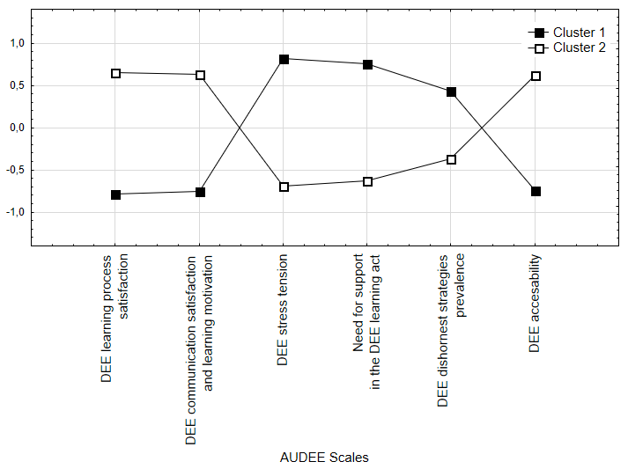
Fig. 1. k-means cluster analysis results

Any materials, theory, statement, study published earlier shall be compulsory followed by a reference to a source of literature.
For literature reference, after-text references are used (they are specified in references). All sources included in references list shall be referenced in square brackets in text of the article. Reference to literature source is typed after name or citation. Reference to source is a number of the source in references only and is typed in square brackets. Example: [5]. If several sources are referenced, number of sources are typed in square brackets with a semicolon between the sources. The sources are enumerated in ascending order. Example: [3;10]. In citation pages in brackets are typed after number of the source with a comma. Example: [4, p.12].

References
1. Dubrovina I.V. Idei L.S. Vygotskogo o soderzhanii detskoi prakticheskoi psikhologii [Ideas L.S. Vygotsky on the content of children’s practical psychology]. Psikhologo-pedagogicheskie issledovaniya [Psychological-Educational Studies], 2013, no. 3. Available at: http://psyedu.ru/ journal/2013/3/3432.phtml (Accessed 18.11.2013). (In Russ.).
2. Zabrodin Yu.M., Metelkova E.I., Rubtsov V.V. Conception and Organizational and Structural Models of Psychological Service in Education. Psikhologo-pedagogicheskie issledovaniya [Psychological-Educational Studies], 2016. Vol. 8, no. 3, pp. 1–15. DOI:10.17759/psyedu.2016080301. (In Russ.).
3. Blair C. How similar are fluid cognition and general intelligence? A developmental neuroscience perspective on fluid cognition as an aspect of human cognitive ability. Behavioral Brain Science, 2006. Vol. 29, no. 2, pp. 109–125. DOI:10.1017/S01405 25X06009034

Information about the authors
Vitalyi N. Ivanov, PhD in Psychology, Leading Research Associate, Associate Professor, Chair of Psychology, Saint Petersburg State University, Saint Petersburg, Russia, ORCID: https://orcid.org/0000-0002-0777-1111, e-mail: ivanov@yandex.ru
Vladimir N. Petrov, PhD in Psychology, Leading ResearchAssociate, CenterofApplied Psychological Studies, Moscow State University of Psychology & Education, Moscow, Russia, ORCID: https://orcid.org/0000-0002-0777-1122, e-mail: petrov@yandex.ru

